### 

### 

**Thesis Submission Recap 4**

Question to be answered during the research: 5

**Market Research 6**

Three overarching goals for the US health system: 6

1) Access 6

2) Equity 6

3) Affordability 6

Three highest barriers in the US health system: 6

1) Fee for service Care Model 6

2) Multi-payer Insurance Healthcare Model 6

3) Non Universal Healthcare Coverage 7

Which people are suffering the most in the USA in terms of low quality in healthcare? 7

Why? 7

Do these vulnerable patients have insurance, but also high copayments / high deductibles? Or are these vulnerable patients unable to get insurance, and fully exposed to the catastrophic financial consequences of a health issue? 7

Financial support in Rural Areas 9

1. Medicaid: 9

a. Purpose: 9

b. Eligibility Criteria 9

c. Benefits 9

i. Coverage 9

ii. Access to care 9

iii. Economic Measures 9

d. Application 9

2. Marketplace Coverage (Health Insurance Exchange 9

a. Purpose: 9

b. Eligibility Criteria 9

c. Benefits 9

i. Coverage 9

ii. Access to care 9

iii. Economic Measures 9

d. Application 9

3. Tax Credits (Premium Tax Credits) 9

a. Purpose: 9

b. Eligibility Criteria 9

c. Benefits 9

d. Application 9

Medicaid 9

Explanation and initiatives 9

Affordable Marketplace Plan 9

Explanation and initiatives 9

Tax credits in Rural Areas 10

Explanation and initiatives 10

Federal poverty level 10

Explanation of every FPL and the benefits and eligibility 10

Total number of uninsured non-elderly population per states which have not expanded Medicaid 10

I found a dataset and i made some analytical assumptions and correlations 10

Coverage gap 10

Explanation and stats 10

Potential eligibility for states if Medicaid expanded 10

Stats 10

Non-financial barriers to Healthcare 10

Analysis: 10

Top three influencing factors: 15

1. Provider Availability: 15

Provider availability + Low Patient Volume in Rural Healthcare 16

Trends Affecting Rural Hospital Financial Sustainability 17

1.Patient Volume and Health 18

2. Overcoming Low Reimbursement 18

3. Managing Staffing Shortages 19

4. Ensure Fair and Adequate Reimbursement: 20

5. Support Telehealth Coverage: 21

6..Boosting and Incentivising Workforce: 21

National Health Service Corps 22

Income-Share Agreement (ISA) in Healthcare: 23

Advantages of the ISA Scenario: 23

Disadvantages of the ISA Scenario: 24

Promising startups addressing the barrier in HealthCare in Rural Areas 25

1. Main Street Health https://mainstreetruralhealth.com/ (USA) 25

2. Homeward Health (USA) 27

3. Hi.health (Austria) 28

4. Walnut(USA) 29

5. ProCredEx (USA) 30

Potential Solution 32

Leveraging Fintech (Aleksandra’s opinion) 32

What kind of solution would address 1. Patients awareness (non-elderly) for eligibility and financial assistance + 2. Medicaid Providers incentives to work in Rural hospitals + overcoming low reimbursement for hospitals in rural areas? 32

Diagram of Eligibility Checks: 32

Healthcare Ecosystem Prototype with Real-World Companies and Clear Input-Output Relationships 36

Integrated Flow Breakdown 36

Step 1: Camper Health (Patient Journey Begins) 36

Step 2: Camper Health → Homeward Health (Eligibility Sharing for Telehealth Services) 36

Step 3: Homeward Health → Main Street Health (Visit Data Sharing for Care Coordination) 36

Step 4: Main Street Health → ProCredEx (Care Summary and Credentialing Data Sharing) 37

Step 5: ProCredEx → Lilian Care (Credential Data for Provider Incentives) 37

Step 6: Lilian Care → ProCredEx (Incentive Data Feedback for Compliance Reporting) 37

Step 7: ProCredEx → Hi.Health (Claims Processing Data for Validation) 37

Step 8: Hi.Health → Walnut (Payment Plan Status & Reimbursement Data) 38

Step 9: Walnut → Camper Health (Communication of Financial Assistance Status) 38

Summary of Workflow Starting with Camper Health (and Including Lilian Care and Hi.Health): 38

What kind of solution would address 1. Patients awareness (non-elderly) for eligibility and financial assistance + 2. Medicaid Providers incentives to work in Rural hospitals + overcoming low reimbursement for hospitals in rural areas? 40

This integrated system of existing solutions if they work together as one ecosystem. 40

Problem 1: Patients’ Awareness (Non-Elderly) for Eligibility and Financial Assistance 40

Solution: 40

How the Integrated System Solves the Problem: 41

Problem 2: Medicaid Providers' Incentives to Work in Rural Hospitals 41

Solution: 41

How the Integrated System Solves the Problem: 41

Problem 3: Overcoming Low Reimbursement for Hospitals in Rural Areas 42

Solution: 42

How the Integrated System Solves the Problem: 42

Summary of Problems Solved by the Integrated System 43

Three Different Patient Scenarios 43

1. Scenario 1: Low-income family, Medicaid and CHIP eligible. 44

2. Scenario 2: Mid-income individual, eligible for marketplace coverage. 44

3. Scenario 3: Senior individual with disability, eligible for Medicaid and Medicare. 44

### 

### 

# Thesis Submission Recap

The integration of fintech solutions into the healthcare sector has the potential to revolutionize

* financial inclusion. As technology continues to advance, there is a unique opportunity to explore how
* fintech tools, such as innovative payment solutions, innovative insurance reimbursement models, and
* strategic financial incentives can alleviate financial barriers to healthcare access. This study is
* motivated by the pressing need to understand the impact of these solutions and their potential to
* bridge the financial gaps that often hinder individuals from seeking necessary healthcare services.
* 2. Goals and Added Value:
* The primary goal is to investigate how the synergy between fintech and healthcare can enhance
* financial inclusion. The added value of this investigation lies in providing insights into practical
* strategies for leveraging fintech tools, thereby facilitating better access to healthcare services. By
* understanding the dynamics of health savings accounts, microinsurance, and payment solutions,
* furthermore I would develop new alternatives to microinsurance or health savings account
* approaches. Afterwards an insightful comparative analysis with valuable insight would be made on my
* newly introduced solutions vs the already existing one which would be beneficial for policymakers,
* healthcare providers, and fintech developers, ultimately fostering a more inclusive and accessible
* healthcare system.
* 3. Research Questions:
* ● Which people are suffering the most in the USA in terms of financial barriers in healthcare ?
* ● Do these vulnerable patients have insurance, but also high copayments / high deductibles? Or
* are these vulnerable patients unable to get insurance, and fully exposed to the catastrophic
* financial consequences of a health issue?
* ● What are the limitations and challenges associated with current insurance plans and
* reimbursement approaches, and how can innovative alternatives address these
* shortcomings?
* ● How do the newly proposed alternatives to enhanced access in healthcare and fintech
* solutions impact financial inclusion in healthcare, and how do they compare to traditional
* solutions in terms of accessibility, affordability, and effectiveness?
* Research Approach:
* To achieve the outlined goals and answer the research questions, a mixed-methods approach
* will be employed. The study will involve a comprehensive literature review to establish the
* current landscape and identify gaps in knowledge. This will include a qualitative analysis
* focusing on the most affected regions and the socio-economic factors inﬂuencing uninsured
* populations, particularly in the USA, where signiﬁcant healthcare investments coexist with low
* quality and high rates of dissatisfaction and lack of insurance.
* In-depth qualitative interviews and surveys with healthcare consumers, providers, and ﬁntech
* experts will provide nuanced insights. Additionally, a prototype of an actual implementation of
* asset management system regarding healthcare saving accounts will be developed.
* Quantitative analysis will be conducted to assess the feasibility and potential adoption rates
* of the proposed solution.
* The research will also explore case studies of successful ﬁntech implementations in
* healthcare from various regions in the USA, providing a comprehensive understanding of the
* challenges and opportunities in this ﬁeld.
* 4. Keywords:
* Fintech
* Financial Inclusion
* Healthcare Access
* Health Savings
* Accounts
* Microinsurance
* Payment Solutions
* Technology Integration
* Inclusive Healthcare
* Financial Barriers
* Healthcare Innovation

### 

### **Question to be answered during the research:**

Ultimate question to be answered: How do the newly proposed alternatives to enhanced access in healthcare and fintech solutions impact financial inclusion in healthcare, and how do they compare to traditional solutions in terms of accessibility, affordability, and effectiveness?

1. Which people are suffering the most in the USA in terms of financial barriers in healthcare and why?
   1. Which social factors do you believe have the most significant influence on healthcare access, considering aspects such as age, racism, gender, geographical location, education, and financial stability?
   2. Do these vulnerable patients have insurance, but also high copayments / high deductibles? Or are these vulnerable patients unable to get insurance, and fully exposed to the catastrophic financial consequences of a health issue?
2. What are the limitations and challenges associated with current insurance plans and reimbursement approaches, and how can innovative alternatives address these shortcomings?
3. In what ways can innovative alternatives address the identified shortcomings in insurance services, thereby enhancing financial inclusion and healthcare access in these regions?

# Market Research

## Three overarching goals for the US health system:

### Access

### Equity

### Affordability

## Three highest barriers in the US health system:

### Fee for service Care Model

***Highest challenge:***The highest challenge is the financial risk associated with the Value-Based Care model, as healthcare providers express reluctance due to concerns about long-term profitability and optimization, which contrasts with the pursuit of immediate profit.

### Multi-payer Insurance Healthcare Model

***Highest challenge:*** The highest is the skepticism and fear among Americans regarding the shift to a single-payer healthcare system, rooted in historical concerns about government authority. Critics worry about potential inefficiencies, long lines, delays, and increased bureaucracy, reflecting a broader hesitation to embrace a government-run healthcare system.(There is still a multi-payer vs single-payer debate among the population and the political parties as well)

### Non Universal Healthcare Coverage

***Highest challenge:*** The highest challenge is the lack of political will and consensus in the U.S., which hinders the establishment of a single-payer system or universal health coverage, leading to resistance and political gridlock.

Four features distinguish top performing countries in the overall ranking of the healthcare system from the United States:

1) they provide for universal coverage and remove cost barriers

2) they invest in primary care systems to ensure that high-value services are equitably available in all communities to all people

3) they reduce administrative burdens that divert time, efforts, and spending from health improvement efforts

4) they invest in social services, especially for children and working-age adults.

## Which people are suffering the most in the USA in terms of low quality in healthcare?

Age: 19-64y

Ethnicity: Black population, Hispanic population

Gender: Female

Region: South and West region

## Why?

1. Low income
2. Rural areas, South and West areas (no Medicaid, no Marketplace plan coverage, no Access to Healthcare providers)
3. Financial illiteracy( No awareness for eligibility, No awareness of opportunities)
4. Racism?

### **Do these vulnerable patients have insurance, but also high copayments / high deductibles? Or are these vulnerable patients unable to get insurance, and** **fully exposed to the catastrophic financial consequences of a health issue?**

The focus of the information is primarily on the challenges faced by the uninsured, exposing them to catastrophic financial consequences in the event of a health issue. The data indicates that the uninsured population, despite its size, experienced disparities in coverage eligibility based on factors such as Medicaid expansion, immigration status, and affordability of Marketplace plans.

Regarding high copayments and deductibles, the information mentions that the difficulty in affording coverage is a prominent reason for lacking insurance among uninsured nonelderly adults. This suggests that for some individuals, even if they have insurance, the associated costs such as high copayments and deductibles may still present challenges, contributing to their vulnerability.

Opportunities, initiatives, solutions for overcoming barriers for the most affected uninsured people in rural areas

### Financial support in Rural Areas

### Medicaid:

#### Purpose:

#### Eligibility Criteria

#### Benefits

##### Coverage

##### Access to care

##### Economic Measures

#### Application

### Marketplace Coverage (Health Insurance Exchange

#### Purpose:

#### Eligibility Criteria

#### Benefits

##### Coverage

##### Access to care

##### Economic Measures

#### Application

### Tax Credits (Premium Tax Credits)

#### Purpose:

#### Eligibility Criteria

#### Benefits

#### Application

### Medicaid

#### Explanation and initiatives

### Affordable Marketplace Plan

#### Explanation and initiatives

### Tax credits in Rural Areas

#### Explanation and initiatives

### Federal poverty level

#### Explanation of every FPL and the benefits and eligibility

### Total number of uninsured non-elderly population per states which have not expanded Medicaid

### I found a dataset and i made some analytical assumptions and correlations

#### Coverage gap

### Explanation and stats

#### Potential eligibility for states if Medicaid expanded

#### Stats

### Non-financial barriers to Healthcare

#### Analysis:

Alabama:

* 1. Uninsured Rate: 11%
  2. Rural Population: 42.3%
  3. Rural Area and Density: Considerable
  4. Influencing Factors:
     + Substantial rural population and lower rural population density contribute to a higher uninsured rate.
     + Employment-related healthcare gaps from jobs in the Trade Industry.
     + Challenges in healthcare literacy due to the prevalence of individuals with less than a High School Diploma.

Florida:

* 1. Uninsured Rate: 16%
  2. Rural Population: 8.5%
  3. Rural Area and Density: Lower
  4. Influencing Factors:
     + Diverse population contributes to the higher uninsured rate.
     + Lower rural population and density may impact healthcare accessibility.
     + Percentages in the Education/Health Industry could also play a role.
     + Florida's unique demographic makeup may contribute to challenges in healthcare understanding.

Georgia:

* 1. Uninsured Rate: 15%
  2. Rural Population: 25.9%
  3. Rural Area and Density: Considerable
  4. Influencing Factors:
     + Considerable rural population and moderate rural population density lead to a notable uninsured rate.
     + Influence of the Entertainment Industry contributes to employment-related gaps in coverage.
     + Georgia's education factor may impact healthcare literacy.

Kansas:

* 1. Uninsured Rate: 10%
  2. Rural Population: 27.7%
  3. Rural Area and Density: Significant
  4. Influencing Factors:
     + Significant rural population and lower rural population density contribute to a lower uninsured rate.
     + Presence of the Manufacturing industry and a higher percentage of individuals with less than a High School Diploma could contribute to more accessible healthcare.
     + The education factor in Kansas may play a role in healthcare literacy.

Mississippi:

* 1. Uninsured Rate: 16%
  2. Rural Population: 53.7%
  3. Rural Area and Density: Considerable
  4. Influencing Factors:
     + Large rural population, lower rural population density, and challenges in accessing healthcare contribute to the highest uninsured rate.
     + Presence of the Entertainment Industry and economic disparities play a significant role.
     + Mississippi's education factor may affect healthcare understanding.

North Carolina:

* 1. Uninsured Rate: 12%
  2. Rural Population: 33.3%
  3. Rural Area and Density: Significant
  4. Influencing Factors:
     + Diverse economy, substantial rural population, higher rural population density, and a higher percentage of individuals with less than a High School Diploma contribute to the moderate uninsured rate.
     + Presence of the Manufacturing and Education/Health industries may lead to variations in coverage.
     + Education factor in North Carolina may impact healthcare literacy.

South Carolina:

* 1. Uninsured Rate: 12%
  2. Rural Population: 32.1%
  3. Rural Area and Density: Significant
  4. Influencing Factors:
     + Significant rural population impacted by the Entertainment and Service industries.
     + Economic factors, access challenges, and a higher percentage of individuals with less than a High School Diploma contribute.
     + Education factor in South Carolina may affect healthcare literacy.

South Dakota:

* 1. Uninsured Rate: 11%
  2. Rural Population: 42.8%
  3. Rural Area and Density: High
  4. Influencing Factors:
     + High rural population, lower rural population density, and challenges in the Entertainment Industry contribute to the moderate uninsured rate.
     + Economic factors and a higher percentage of individuals with less than a High School Diploma play a role.
     + Education factor in South Dakota may impact healthcare literacy.

Tennessee:

* 1. Uninsured Rate: 11%
  2. Rural Population: 33.8%
  3. Rural Area and Density: Significant
  4. Influencing Factors:
     + Significant rural population, higher rural population density, and percentages in the Manufacturing and Education/Health industries contribute to the moderate uninsured rate.
     + Economic disparities, access challenges, and a higher percentage of individuals with less than a High School Diploma play a role.
     + Education factor in Tennessee may impact healthcare literacy.

Texas:

* 1. Uninsured Rate: 19%
  2. Rural Population: 16.3%
  3. Rural Area and Density: Lower
  4. Influencing Factors:
     + Highest uninsured rate, possibly due to a lower rural population and density.
     + Challenges from the Trade and Service industries.
     + Significant proportion with less than a High School Diploma contributes to the challenges in healthcare coverage.
     + Education factor in Texas may affect healthcare literacy.

Wisconsin:

* 1. Uninsured Rate: 6%
  2. Rural Population: 32.9%
  3. Rural Area and Density: Significant
  4. Influencing Factors:
     + Lowest uninsured rate influenced by a substantial rural population, moderate rural population density, percentages in the Manufacturing industry, and a higher percentage of College Graduates.
     + Successful Medicaid outreach likely contributes to better healthcare coverage.
     + Education factor in Wisconsin may impact healthcare literacy positively.

Wyoming:

* 1. Uninsured Rate: 14%
  2. Rural Population: 38%
  3. Rural Area and Density: Lower
  4. Influencing Factors:
     + Moderate uninsured rate influenced by a moderate rural population, lower rural population density, challenges in the Trade Industry, and a higher percentage of individuals with less than a High School Diploma.
     + Economic factors and access to healthcare services contribute to this rate.
     + Education factor in Wyoming may play a role in healthcare literacy.

Based on the provided information, the states facing the highest challenges in accessing healthcare facilities due to factors such as a higher uninsured rate, substantial rural population, lower rural population density, and potential barriers in healthcare literacy are the following:

Mississippi:

* + - Large rural population and lower rural population density.
    - Challenges in accessing healthcare services.
    - Presence of the Entertainment Industry contributing to potential employment-related gaps.
    - Economic disparities play a significant role.

Texas:

* + - Highest uninsured rate among the states.
    - Lower rural population and density.
    - Challenges from the Trade and Service industries.
    - A significant proportion with less than a High School Diploma, contributing to healthcare coverage challenges.

Georgia:

* + - Considerable rural population and moderate rural population density.
    - Challenges in healthcare access.
    - Influence of the Entertainment Industry contributing to employment-related gaps.
    - Potential impact on healthcare literacy due to educational factors.

### Top three influencing factors:

#### Provider Availability:

* 1. Moderate Rural Population Density (e.g., Georgia):
     1. *Characteristics:* Regions with moderate rural population density often have a balanced distribution of residents across geographic areas.
     2. *Healthcare Infrastructure:* While there may be some healthcare infrastructure, it is not as extensive as in urban areas, leading to challenges in meeting the healthcare needs of the local population.
     3. *Travel Distances:* Residents may experience moderate travel distances to access healthcare services, with healthcare facilities more evenly distributed compared to areas with lower rural population density.
  2. Lower Rural Population and Density (e.g., Texas):
     1. *Characteristics:* Areas with lower rural population and density have fewer residents scattered across larger geographic spaces.
     2. *Healthcare Facilities:* The number of hospitals, clinics, and healthcare professionals is limited, resulting in fewer healthcare facilities available.
     3. *Increased Travel Distances:* Residents in these areas often face longer travel distances to reach healthcare providers, making it more challenging to access timely medical services.
  3. Large Rural Population with Lower Rural Population Density (e.g., Mississippi):
     1. *Characteristics:* Regions with a large rural population and lower rural population density have a significant number of residents spread across expansive areas.
     2. *Healthcare Challenges:* Inherent challenges arise due to the increased geographical distances between residents and potential scarcity of medical facilities.
     3. *Access Hurdles:* The combination of a large rural population and lower rural population density intensifies the barriers to healthcare access. Residents may encounter greater difficulties in reaching healthcare providers promptly.

1. **A significant proportion with less than a High School Diploma, contributing to healthcare coverage challenges:** The significant proportion of the population with less than a High School Diploma in Texas may correlate with lower health literacy levels. Limited understanding of healthcare information can hinder individuals from navigating the healthcare system effectively and making informed decisions about their well-being.
2. **Presence of the Entertainment Industry, Trade and Service Industries:** These Industries often rely on irregular employment structures, such as freelance or part-time work, leading to inconsistent access to employer-sponsored healthcare benefits. This can result in gaps in coverage and higher uninsured rates. Jobs in the Trade and Service industries may be associated with lower income levels. Lower-income individuals may face challenges in affording health insurance coverage or medical expenses, contributing to higher uninsured rates. These industries may not always provide comprehensive employer-sponsored health insurance, leaving employees to seek coverage through other means. In the absence of affordable options, individuals may remain uninsured.

#### Provider availability + Low Patient Volume in Rural Healthcare

Non-Financial Barriers to Care in rural areas persist despite improvements in insurance coverage. Public hospitals, community clinics, health centers, and local providers catering to underserved communities play a crucial role in providing a healthcare safety net for uninsured individuals. However, these safety net providers face limitations in resources and service capacity, and not all uninsured individuals have geographical access to such providers. High uninsured rates contribute to rural hospital closures and present greater financial challenges for rural hospitals, placing individuals in rural areas at a heightened disadvantage in accessing care. Research indicates that Medicaid expansion is associated with reductions in uncompensated care costs and improved financial performance for rural hospitals and other healthcare providers.

Provider availability stands out as a significant challenge, especially for physicians, with rural areas experiencing ongoing shortages in various specialties and primary care. Some rural regions, affected by the overdose crisis, face additional hurdles due to a lack of behavioral health specialists, hindering treatment for substance use disorders. The shortage of healthcare professionals is evident in the ratio of providers per 10,000 persons, as highlighted in Table 4. To combat these geographic imbalances, the U.S. Department of Health and Human Services (HHS) designated Health Professional Shortage Areas (HPSAs), directing resources to address provider shortages. Primary care HPSAs, crucial for programs like the National Health Service Corps and Nurse Loan Repayment, are predominantly located in rural areas, as illustrated in Figure 6. This underscores the need for targeted efforts to enhance healthcare accessibility in underserved regions.

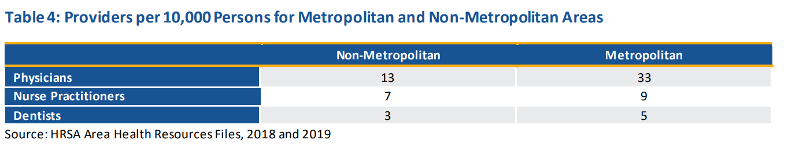

[<https://www.kff.org/uninsured/issue-brief/key-facts-about-the-uninsured-population/>]

[<https://www.kff.org/racial-equity-and-health-policy/issue-brief/health-coverage-by-race-and-ethnicity/#:~:text=Nonelderly%20AIAN%20and%20Hispanic%20people%20had%20the%20highest,than%20the%20rate%20for%20their%20White%20counterparts%20%286.6%25%29>.]

#### Trends Affecting Rural Hospital Financial Sustainability

Analysis for Rural Hospital Closures Threaten Access

From 2010 to 2021, a total of 136 rural hospitals shut down, as reported by the UNC Cecil G. Sheps Center. The year 2020 saw the highest number of closures in the past decade, with nineteen hospitals ceasing operations.

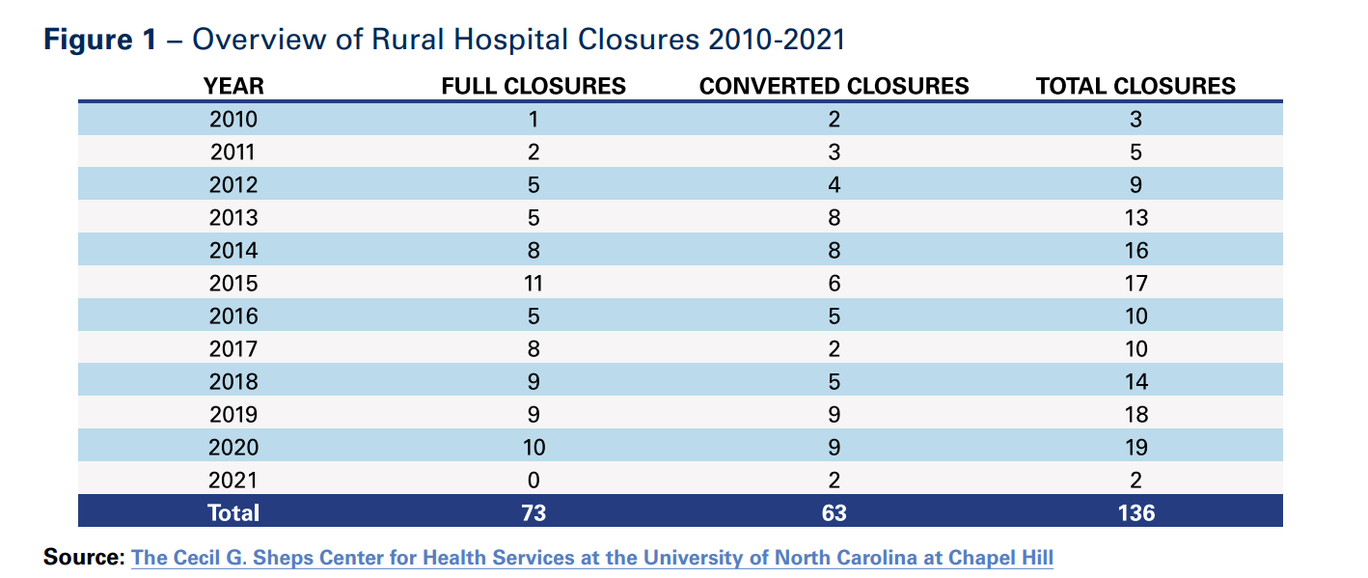

• The majority (74%) of these rural closures occurred in states without Medicaid expansion or where expansion had been in place for less than a year.

• Rural hospitals grapple with significant staffing shortages, with only 10% of physicians in the United States practicing in rural areas, despite these areas accounting for 14% of the population. Additionally, nearly 70% of primary care Health Professional Shortage Areas (HPSAs) are located in rural or partially rural regions.

• An analysis by the American Hospital Association (AHA) of UNC Sheps Center data from 2010 to 2020 indicates that slightly more than half of the closed hospitals were independent.

• Despite ongoing challenges, various pathways exist for ensuring the financial sustainability of rural hospitals.

In 2020, rural hospitals supported one in every 12 rural jobs in the U.S. as well as $220 billion in economic activity in rural communities.

##### 1.Patient Volume and Health

Rural areas experience lower population densities, resulting in rural hospitals facing challenges associated with maintaining fixed-operating costs due to lower patient volumes. The COVID-19 pandemic has exacerbated this issue, leading to more volatile patient volumes and acuity. Lower patient volumes also hinder participation in performance measurement and quality improvement activities, making it challenging for rural hospitals to identify areas of success or improvement.

Furthermore, rural hospitals may struggle to obtain statistically reliable results for some performance measures, limiting their participation in innovative payment models and alternative revenue streams. In addition to lower patient volumes, rural hospitals often serve older, sicker, and poorer populations compared to the national average. A significant percentage of rural patients are uninsured, leading to delayed care-seeking due to cost, contributing to sicker and more costly patients.

Geographic isolation and limited transportation access in rural areas exacerbate delays in care-seeking, placing additional strain on rural health systems. Overall, the challenging patient mix and lower volumes in rural areas make it difficult for these health systems to provide care with the varied and intense resources needed, distinguishing them from other regions.

##### 2. Overcoming Low Reimbursement

Rural hospitals heavily rely on government payers, with Medicare constituting nearly half of their revenue. However, both Medicare and Medicaid reimburse less than the cost of services, resulting in significant underpayments. In 2020, rural hospitals incurred $5.8 billion in Medicare underpayments, $1.2 billion in Medicaid underpayments, and provided $4.6 billion in uncompensated care. Medicare underpayments grew by almost 40% from 2016 to 2020. The expiration of relief programs, such as the Medicare-dependent Hospital (MDH) and enhanced Low-volume Adjustment (LVA) program, scheduled for September 30, 2022, poses financial challenges, especially for one in five rural closures in 2020 that were MDHs.

In the commercial insurance market, rural hospitals often face below-average rates or exclusion from plan networks. This lack of negotiation power can lead to unfavorable terms, impacting patient access. Exclusion from certain plan networks due to unfair insurer tactics hampers patient access in rural areas, where long distances are already a factor. Additionally, affordable coverage remains a challenge, with lack of health insurance resulting in high uncompensated care costs for hospitals. Medicaid expansion has proven crucial for rural hospital viability, with 74% of closures occurring in states without or with less than a year of Medicaid expansion. Research by the American Hospital Association indicates that Medicaid expansion is associated with improved hospital financial performance and a lower likelihood of closure, particularly in areas with high uninsured rates before expansion.

##### 3. Managing Staffing Shortages

Rural hospitals grapple with significant staffing shortages, with only 10% of physicians practicing in rural areas despite these areas accounting for 20% of the population. Nearly 70% of primary care Health Professional Shortage Areas (HPSAs) are situated in rural or partially rural regions. This shortage of primary care services adversely impacts rural populations, leading to lower health outcomes compared to more densely populated areas. Additionally, behavioral health and substance abuse professional shortages are prominent, with 65% of rural counties lacking psychiatrists, 47% without psychologists, and 81% lacking psychiatric nurse practitioners.

The COVID-19 pandemic has exacerbated existing staffing challenges, with nearly one-third of hospitals anticipating critical staffing shortages during the January 2022 omicron surge. To address these shortages, hospitals have resorted to expensive contract labor firms, resulting in a more than doubling of average pay for hospital contract nurses. This has increased labor expenses by over 50% on a per adjusted discharge basis compared to pre-pandemic levels, posing a significant financial burden, especially for rural hospitals already facing negative operating margins.

Recruitment and retention of health professionals in rural areas have been persistent challenges, intensified by acute workforce shortages and rising labor expenses due to the pandemic. Rural hospitals are exploring novel approaches and federal programs, such as the National Health Service Corps and the Rural Public Health Workforce Training Network Program, to incentivize clinicians and expand public health capacity. Continued support from state and federal governments is crucial to address these challenges in recruiting and retaining healthcare professionals in rural areas.

Opportunities:

Rural hospitals received COVID-19 relief funds from the CARES Act and the American Rescue Plan Act, providing critical support and temporarily slowing rural closures. However, as these funds deplete, rural hospitals may face financial challenges. Only two rural hospitals closed in 2021, thanks to relief, but without additional support and halted payment cuts, more closures are anticipated.

The Centers for Medicare & Medicaid Services (CMS) expanded telehealth services during the pandemic, benefiting rural hospitals. Still, these waivers may expire without congressional action, endangering progress in increasing patient access.

To address challenges, rural hospitals can implement new care models, such as the Community Health Access and Rural Transformation (CHART) value-based payment model and the Rural Emergency Hospital designation under Medicare. Regulatory burdens hinder rural hospitals, and addressing outdated regulations can protect community access to healthcare.

Partnerships, collaborations, mergers, and affiliations can be effective for rural hospitals to preserve access to care. Despite claims that consolidation drives closures, data show that system affiliation is not a significant factor in rural hospital closures. Integrations can enhance quality of care, provide resources, and facilitate partnerships with larger employers, offering rural hospitals the ability to obtain affordable capital.

[<https://www.aha.org/system/files/media/file/2022/09/rural-hospital-closures-threaten-access-report.pdf>]

##### 4. Ensure Fair and Adequate Reimbursement:

* Update reimbursement rates across payers to cover the cost of care in rural areas.
* Reverse Rural Health Clinic (RHC) payment cuts to maintain access to primary care.
* Extend ambulance add-on payments to safeguard emergency medical care access.
* Provide flexibility for Critical Access Hospitals (CAHs) through regulatory adjustments.
* Support the Save Rural Hospitals Act to establish a wage index floor for hospitals.

##### 5. Support Telehealth Coverage:

* Permanently eliminate restrictions on originating sites and geographic locations.
* Remove in-person visit requirements for behavioral telehealth.
* Extend reimbursement parity based on the place of service.
* Continue payment and coverage for audio-only telehealth services.
* Expand eligible provider types and remove unnecessary licensure barriers.
* Establish DEA Special Registration Process for Telemedicine for controlled substance administration.
* Promote cross-agency collaboration on digital infrastructure and literacy initiatives.

##### 6..Boosting and Incentivising Workforce:

3.1 Graduate Medical Education:

* Urges Congress to pass the Resident Physician Shortage Reduction Act of 2023 (S. 1302).
* Aims to increase the number of Medicare-funded residency slots, addressing shortages, particularly in rural areas.

3.2 Conrad State 30 Program:

* Urges Congress to pass the Conrad State 30 and Physician Access Reauthorization Act (S. 665).
* Seeks an extension of the Conrad State 30 J-1 visa waiver program, benefiting physicians agreeing to serve in federally-designated underserved areas.

3.3 Loan Repayment Programs:

* Urges Congress to pass the Restoring America’s Health Care Workforce and Readiness Act (S. 862).
* Aims to significantly expand National Health Service Corps funding, providing incentives for clinicians to practice in underserved areas, including rural communities.
* Supports the Rural America Health Corps Act (S. 940) to establish a dedicated program targeting rural workforce shortages through focused loan repayment initiatives.

3.4. Boost Nursing Education:

* Urges Congress to invest $1 billion in supporting nursing education.
* Calls for resources to enhance student and faculty populations, modernize infrastructure, and foster partnerships and research at schools of nursing.
* Expresses support for expanding the National Nurse Corps.

3.5. Health Care Workers Protection:

* Urges Congress to enact federal protections for healthcare workers, addressing violence and intimidation.
* Advocates for hospital grant funding to support violence prevention training programs.
* Encourages coordination with state and local law enforcement to enhance the safety of healthcare workers.

[https://www.aha.org/system/files/media/file/2023/05/aha-statement-to-senate-finance-committee-subcommittee-on-health-on-improving-rural-health-care-access-5-17-2023.pdf]

##### National Health Service Corps

The National Health Service Corps (NHSC) is a program in the United States that aims to improve access to healthcare services in underserved areas. It is part of the U.S. Department of Health and Human Services (HHS) and operates under the Health Resources and Services Administration (HRSA).

The NHSC was established in 1972 and has since been working to address the shortage of healthcare professionals in rural, urban, and tribal communities. The program provides scholarships and loan repayment assistance to healthcare providers in exchange for their commitment to work in areas with limited access to healthcare services.

Key components of the NHSC include:

* Scholarships: The NHSC Scholarship Program provides financial support to individuals pursuing primary care professions, such as physicians, nurse practitioners, and dentists. In return, recipients commit to serving in NHSC-approved sites in underserved areas upon completion of their training.
* Loan Repayment: The NHSC Loan Repayment Program offers loan repayment assistance to healthcare professionals who agree to work in designated Health Professional Shortage Areas (HPSAs) for a specified period. The program helps to alleviate the financial burden of student loans for those committed to serving in underserved communities.
* Workforce Placement: NHSC works to connect healthcare professionals with communities in need. It supports the placement of providers in areas facing shortages, improving access to care for vulnerable populations.
* Primary Care Training and Technical Assistance: NHSC provides training and technical assistance to healthcare professionals to enhance their skills in delivering primary care services, with a focus on meeting the needs of underserved populations.

##### Income-Share Agreement (ISA) in Healthcare:

Let's consider a healthcare professional named Aleksandra who is a participant in the NHSC program and has opted for an Income-Share Agreement to manage her student loan repayment.

* Agreed Percentage and Duration:
  + Aleksandra agrees to repay 10% of her annual income for a period of 7 years as part of the ISA.
* Initial Income and Repayment:
  + Upon completing her medical training, Aleksandra joins an NHSC-approved site in a rural community. Her starting salary is $80,000 per year.
  + In the first year, Aleksandra's ISA repayment obligation would be $8,000 (10% of $80,000).
* Threshold Adjustments:
  + The ISA includes income thresholds that trigger adjustments to the repayment percentage.
  + If Aleksandra's income falls below $60,000 due to unforeseen circumstances (e.g., taking a sabbatical or working part-time for family reasons), the repayment percentage automatically decreases to 5% until her income surpasses the threshold again.
* Career Advancement and Increased Income:
  + As Aleksandra gains experience and advances in her career, her income increases to $100,000 per year after the third year of service.
  + With the increased income, Aleksandra's repayment obligation rises to $10,000 (10% of $100,000).
* Risk-sharing Mechanism:
  + The ISA includes a risk-sharing mechanism that considers broader economic factors impacting the healthcare industry.
  + In the event of an economic downturn affecting healthcare salaries nationwide, the ISA contract allows for a temporary reduction in the repayment percentage for all participants until economic conditions improve.
* Completion of Agreement:
  + After completing 7 years of service and fulfilling the terms of the ISA, Aleksandra successfully repays a total of $70,000 under the agreement.

###### Advantages of the ISA Scenario:

* Income Alignment: Aleksandra's repayments are directly tied to her income, making it more manageable during lower-earning periods.
* Flexibility: The ISA provides flexibility with threshold adjustments, allowing Aleksandra to adapt to changing life circumstances without incurring financial hardship.
* Risk-sharing: The risk-sharing mechanism acknowledges external factors, ensuring a collaborative approach to loan repayment that considers broader economic conditions.

###### Disadvantages of the ISA Scenario:

Income-Share Agreements (ISAs) are an alternative to traditional student loans, with their roots traced back to Milton Friedman's 1955 essay. Unlike loans, ISAs tie repayments to a student's post-graduation income, making them more aligned with investment principles. Purdue University's "Back a Boiler" program and coding bootcamps like Bloom Institute of Technology offer ISAs, each with unique terms. While ISAs avoid interest and have fixed repayment periods, they lack federal regulation, raising concerns about consumer protection.

Advantages of ISAs include no interest accrual and set repayment periods, but their unregulated nature poses risks. Critics, such as the Student Borrower Protection Center, argue that ISA providers may engage in harmful practices like aggressive collections and potential discrimination based on field of study. A recent study highlighted racial disparities in ISAs, revealing higher costs for students from historically Black colleges and universities (HBCUs) and other minority-serving institutions (MSIs).

Students are advised to carefully assess their options, considering total payback amounts and comparing ISAs with traditional student loans. The suitability of ISAs depends on individual circumstances, and potential risks and benefits should be weighed before opting for this financing method.

However, ISAs, unlike traditional student loans, are not widely accessible. They are predominantly available through four-year colleges, universities, coding bootcamps, other vocational schools, and private lenders.

Purdue University's "Back a Boiler" program is a prominent example of an ISA, determining its income-share rate based on the student's field of study. ISAs associated with higher-paying majors, like chemical engineering, generally feature lower rates and shorter terms compared to those linked to lower-paying majors.

Coding academies, which are career schools specializing in computer programming, have also embraced ISAs for financing. These academies, often lacking accreditation, are ineligible for federal financial aid. For instance, Bloom Institute of Technology (formerly Lambda School) allows graduates to postpone payments until their earnings reach $50,000.

Bloom Institute of Technology. "Our Income Share Agreement."

Private lenders also provide ISAs, and one such example is Stride Funding, an ISA financier. Stride Funding offers students funding of up to $25,000 per school year, which is directly disbursed to their college. The rates are determined by factors such as the student's major, the educational institution they attend, and the anticipated time of earning a paycheck.

### Promising startups addressing the barrier in HealthCare in Rural Areas

#### Main Street Health <https://mainstreetruralhealth.com/> (USA)

Rural America encounters distinctive healthcare obstacles, evident in data indicating reduced access to both primary care and specialist providers. Furthermore, numerous rural hospitals have been compelled to shut down due to financially unsustainable conditions.

Despite the widespread adoption of value-based care in many urban and suburban regions, rural areas exhibit lower participation rates in value-based care compared to their urban and suburban counterparts.

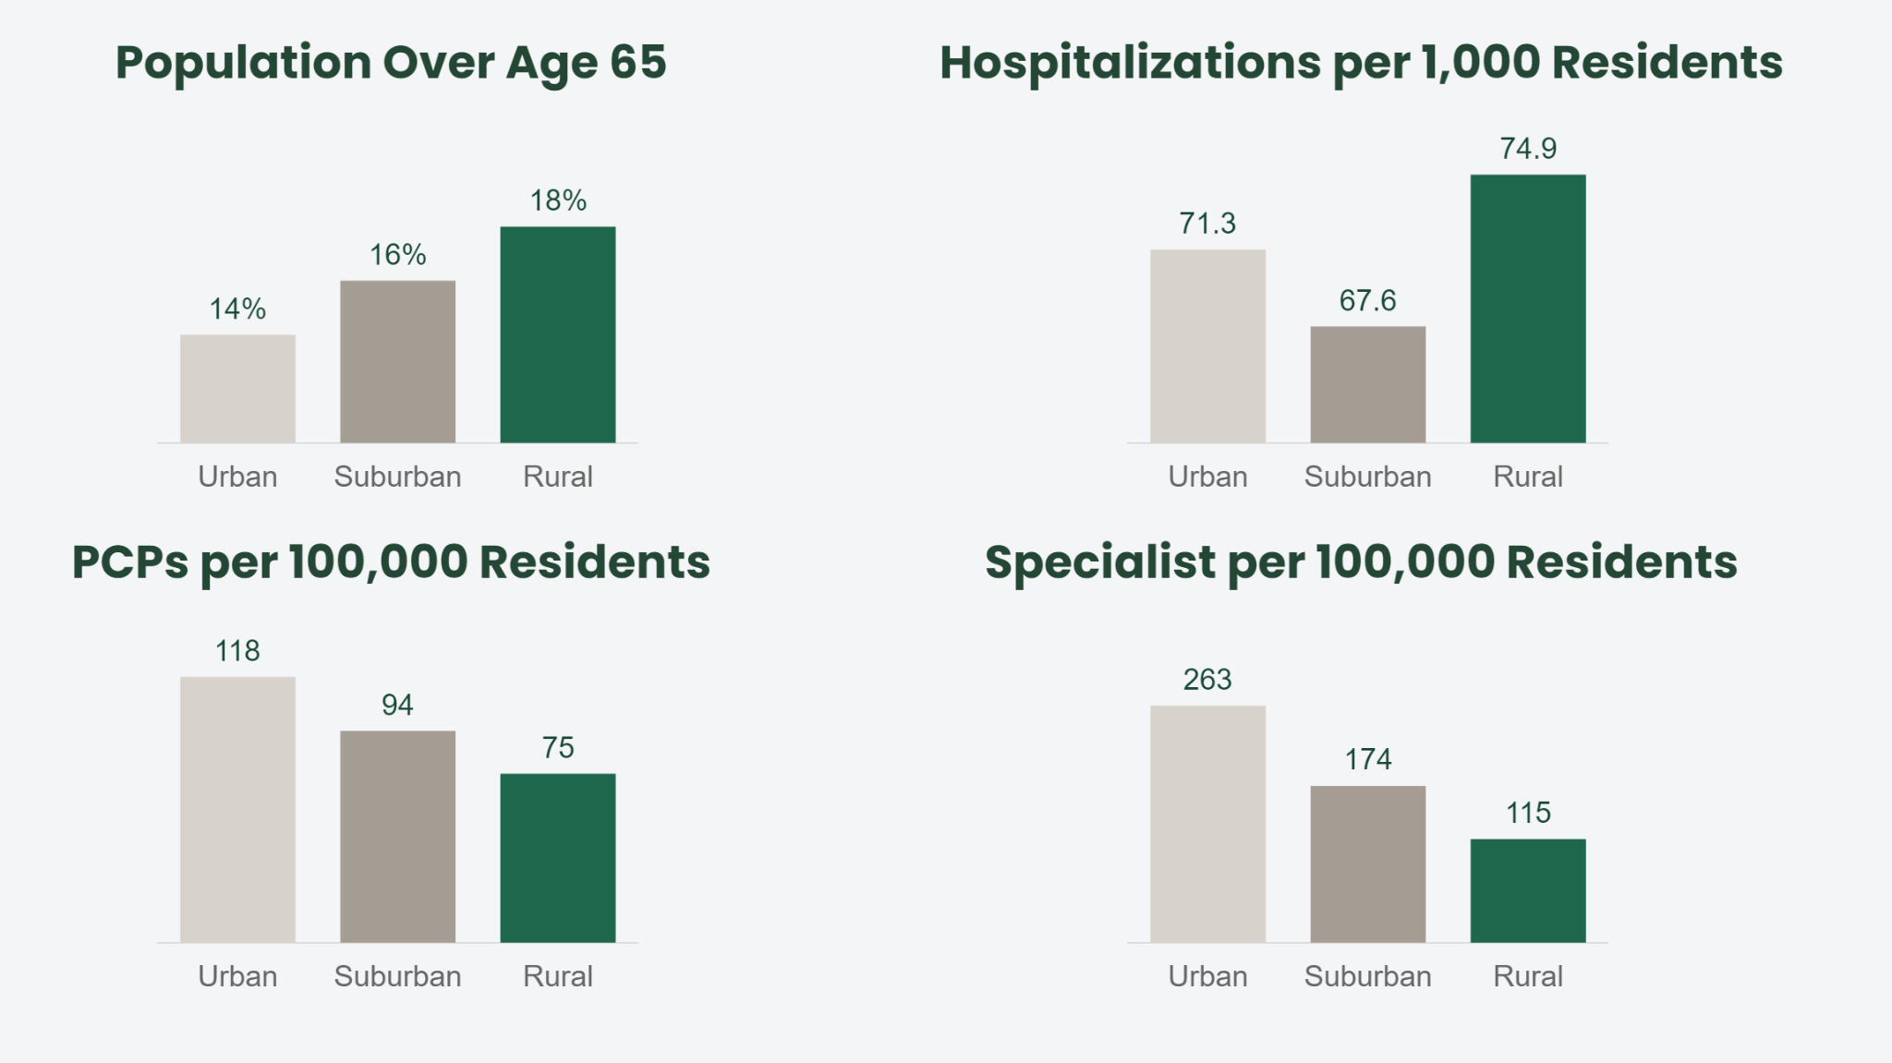

Main Street Rural Health is an organization that partners with various healthcare providers in rural areas to support the transition to value-based care. They collaborate with different types of providers, including small independent private practices, large group private practices, rural health clinics, critical access hospitals, community health centers, and health systems.

Main Street coordinates care for Medicare patients through the Medicare Shared Savings Program, as well as for Medicare Advantage patients.

The partnership involves providing resources such as staff, technology, and opportunities to help these clinics succeed in a value-based delivery model. They specifically mention their local Health Navigators who act as an extra set of hands in the clinic, helping patients navigate care and reducing the burden on clinic staff at no cost to the clinic. They also offer behind-the-scenes data tools to ensure providers have accurate information at the point of care, without the need to learn a new technology system. Main Street provides rural clinics with easy-to-understand recurring payments to reinvest in their practice, patients, and communities.

Main Street Health recently disclosed a $315 million funding round, backed by a company valuation of $2.1 billion, signaling intentions to expand its services into 26 states.

The goal is to help insurance companies spend less on their patients and improve care by stepping in to implement preventative care to avoid more complex diagnoses down the line. Provided it meets clinical quality requirements, Main Street Health is paid by a piece of the shared savings, and from that, it pays clinics a flat fee per month.

During the spring of 2021, EastWood Clinic, a primary care facility located in Paris, Tennessee, experienced a cold call from Main Street Health based in Nashville. The outreach from Main Street Health aimed at exploring potential partnerships in delivering care to rural Medicare patients.

In discussing the challenges faced by smaller clinics in realizing shared savings, it becomes evident that these establishments often lack the necessary human resources and capacity. This situation is described metaphorically as leaving money on the table, a commonly used euphemism. - Josh Roberts, administrator at EastWood Clinic in Paris, Tennessee

From the perspective of Dr. Roberts, the navigators serve as an additional support system for physicians, undertaking tasks that are challenging for nurses and time-consuming for doctors. While Henry County Medical Center caters to many local patient needs, residents often travel to Jackson or Nashville for specialized services. Dr. Roberts expresses a desire for telehealth options to connect rural patients with specialists in larger cities, potentially offering rapid feedback without necessitating a visit to another city for management.

[https://mainstreetruralhealth.com/about-us/]

[<https://www.nashvillepost.com/business/health_care/how-main-street-health-operates-in-rural-clinics/article_2e45e1de-6c74-11ee-81a0-db7c8cd2946a.html>]

#### Homeward Health (USA)

Telemedicine, particularly virtual medical appointments, is on the rise, providing a safer way for physicians and patients to interact amid the COVID-19 pandemic. This approach not only minimizes exposure risks but also improves healthcare access for those residing far from medical facilities.

Homeward Health, a startup founded by former Livongo executives, is employing a hybrid model of in-person and telehealth services to cater to rural communities. Their strategy involves mobile clinics and virtual patient monitoring to simplify healthcare and address infrastructure challenges in rural America. Partnering with Rite Aid, Homeward aims to offer on-site primary care services at up to 700 Rite Aid locations, making healthcare more convenient for rural residents. The company plans to prioritize specialty care, particularly focusing on heart disease, aiming to bridge the treatment gap between rural and urban patients. The use of technology allows for early diagnosis and prevention, resembling an old-school approach of traveling doctors making house calls. Homeward envisions transforming the rural healthcare model to alleviate the workload and burnout experienced by healthcare workers in these areas.

The company revealed in 2022 that it secured $50 million in Series B funding, a mere four months after concluding its $20 million Series A round. ARCH Venture Partners and Human Capital jointly led the new funding round, with involvement from General Catalyst. Additionally, the company disclosed a partnership with Priority Health, a health insurance provider based in Grand Rapids, Michigan. This collaboration aims to offer services to as many as 30,000 Medicare Advantage beneficiaries over the next three years.

Homeward's Care Navigators act as guides, helping individuals comprehend the intricate details of their health insurance benefits. With expertise in deciphering insurance policies, these navigators empower healthcare consumers by providing clarity on covered services and ensuring a full understanding of available benefits.

Locating doctors who align with your insurance can be a daunting task. Homeward's Care Navigators step in to assist in this crucial aspect, facilitating the search for in-network doctors who not only accept your insurance but also match your specific healthcare needs and preferences. It's about ensuring a seamless connection between patients and healthcare providers.

Homeward goes beyond traditional healthcare boundaries by addressing factors crucial to maintaining independence. Care Navigators establish links to local support services, including transportation, meal services, and additional caregiving assistance. This holistic approach ensures individuals have the necessary resources to sustain their independence and well-being.

Homeward's commitment to comprehensive care extends to healthcare coordination. Care Navigators take charge, scheduling appointments on behalf of individuals and facilitating the seamless sharing of medical records between healthcare providers. This ensures a cohesive and integrated healthcare experience.

#### Hi.health (Austria)

In the dynamic landscape of healthcare, hi.health stands out by redefining the claims process through the integration of modern payment solutions. At the core of this transformation is a comprehensive payment card system that not only streamlines reimbursements but also ensures an unparalleled user experience. Here's how hi.health is reshaping the healthcare financial landscape.

Austrian insurtech startup hi.health has successfully secured €6 million in funding from investors such as SpeedInvest, Calm/Storm, Haymarker Ventures, Fin VC, Nina Capital, and others.

Established in 2019, hi.health has developed an application enabling users to effortlessly claim reimbursements for their medical expenses. The process involves users capturing an image of their invoice using the app, following which hi.health handles the submission of invoices to the respective insurers for payment. Noteworthy insurance partners collaborating with hi.health include Allianz Private Krankenversicherung, ARAG, AZA, Ergo Direkt, and HUK-Coburg.

Operating primarily in Germany, the startup extends its services to health service companies through an online checkout solution, hi.direct. This innovative product incorporates a reimbursement feature, enabling customers to make payments for health services or products and directly submit associated costs to their private health insurers during the checkout process.

Since its inception, hi.health has facilitated reimbursements exceeding €50 million, showcasing the impactful success of its user-friendly reimbursement platform.

Modern Payment Solutions for Effortless Claims Processing:

hi.health's solution is designed to eliminate friction in the claims process while implementing effective cost controls. The innovative payment card comes in both tangible and digital formats, providing members with flexibility. Activation of the card grants users global access to healthcare facilities, with payments facilitated seamlessly through insurer funds. The ecosystem also handles any financial gaps, such as co-pays or deductibles, ensuring a hassle-free and financially manageable experience.

Direct Payments and Collaborative Partnerships:

Empowering merchants through direct reimbursement, hi.health collaborates with a diverse range of partners, including online and retail pharmacies, as well as software providers for healthcare professionals. Currently operational in Germany, hi.health is set to expand its services to additional markets, broadening its impact on the healthcare payment landscape.

What hi.health Offers:

* 10x Better User Experience:
  + A payment card in partnership with Visa, providing real-time coverage and swift reimbursements.
  + Transforms the claiming process into a cashless, seamless, and user-friendly experience for insured members.
* Revamped Claims Handling:
  + Intelligent and secure payment card mechanism automating a significant portion of the claims management process.
  + Achieves a remarkable 45-50% time saving in claim processing compared to traditional methods, streamlining operations.
* Reducing Fraud:
  + Direct linkage of each claim to a specific transaction minimizes the potential for fraudulent submissions.
  + Robust anti-fraud algorithms and verification solutions enhance security, ensuring a safer experience for all parties.
* Easy & Seamless Integration:
  + Built with ease of integration in mind, hi.health's payment card system seamlessly merges with an insurer's existing infrastructure.
  + Dedicated technical support ensures swift and efficient setup, minimizing disruption and facilitating the delivery of enhanced services.

#### Walnut(USA)

Walnut employs a "buy now, pay later" framework, a model made popular by companies like Affirm and Klarna, but with a distinct emphasis on healthcare payments. Instead of requiring patients to make a lump-sum payment using their credit cards, Walnut collaborates with healthcare providers to extend the payment period.

The operational model of Walnut unfolds as follows:

Extended Payment Terms: Patients can choose to settle their healthcare bills through manageable $100 monthly increments over a 30-month duration. This approach offers a more gradual and flexible payment structure, easing the burden of managing healthcare expenses.

Data-Driven Underwriting: Walnut utilizes sophisticated underwriting models that transcend conventional credit scoring. Rather than relying solely on credit scores, deemed outdated, Walnut scrutinizes thousands of data points from diverse sources. This includes details about side hustle income and spending habits on essentials like groceries and bills, creating a holistic financial profile for each individual.

Provider Negotiations: Walnut takes a proactive stance in negotiating with healthcare providers. For example, if a provider's collection rate for out-of-pocket expenses stands at 50%, Walnut proposes a mutually beneficial arrangement. They request a 40% discount from the provider and, in return, guarantee upfront cash. This setup enables the provider to receive 60% of the collection rate without exposure to the risks associated with delayed or unpaid payments.

Risk Management: Walnut assumes the financial risks tied to patient payments. By providing upfront cash to providers, even at a discounted rate, Walnut helps mitigate the impact of non-payment or delayed payments. This proves particularly valuable for healthcare providers grappling with challenges related to collecting the full amount owed, often due to factors such as bankruptcies or defaults on payments.

Steady Cash Flow for Providers: While the ideal scenario would involve providers receiving the full 100% of owed payments, the healthcare industry faces the reality that a substantial number of bills go unpaid. The average collections rate for hospital out-of-pocket expenses is less than 20%. Walnut steps in to offer a more dependable upfront cash flow to providers, covering 60% of the overall bills. This not only provides financial security but also ensures predictability in cash flow for healthcare providers.

In essence, Walnut's inventive approach not only benefits patients by introducing a more flexible payment structure but also supports healthcare providers by ensuring a more dependable and timely cash flow, ultimately contributing to the sustainability of the healthcare ecosystem.

#### ProCredEx (USA)

ProCredEx stands out as a trailblazer, setting a new standard by seamlessly integrating collaborative networks, blockchain reliability, a powerful compliance engine, and immediate actionable solutions. This article explores how ProCredEx is transforming the credentialing and compliance landscape, breaking down historical barriers and ushering in a new era of efficiency and reliability.

1. Collaborative Networks: Connecting Compliance Ecosystems

ProCredEx is at the forefront of collaborative networks, serving as a centralized hub that connects every element within the compliance ecosystem. Through a secure and trusted network, data sharing becomes a seamless process, breaking down silos and fostering a community-driven compliance network.

2. Blockchain Reliability: Ensuring Trustworthy Data Management

Leveraging the power of distributed ledger technology, ProCredEx ensures the reliability of data by capturing its provenance, rendering it immutable, and establishing a traceable chain-of-custody. This not only enhances the integrity of compliance records but also eliminates repetitive tasks, setting a new standard for secure and efficient data management.

3. Compliance Engine: Automating and Showcasing Compliance

ProCredEx introduces a robust compliance engine that automatically confirms adherence to relevant standards tailored to each organization. The platform goes beyond mere confirmation, allowing organizations to showcase the quality of their compliance programs through network-wide electronic auditing and reporting. This automated approach simplifies compliance processes and provides real-time insights.

4. Immediately Actionable Solutions: Breaking Down Barriers

ProCredEx takes pride in offering solutions that create immediate value, addressing diverse requirements, data structures, and operational models. Historical barriers to credentialing and compliance are transformed into strategic assets, allowing organizations to navigate compliance challenges with unprecedented efficiency.

Conclusion: Redefining Credentialing and Compliance Dynamics

ProCredEx's innovative approach redefines the dynamics of credentialing and compliance. By integrating collaborative networks, blockchain reliability, a powerful compliance engine, and immediate actionable solutions, ProCredEx propels organizations into a new era where efficiency, security, and reliability become the benchmarks of excellence. As the platform continues to shape the future of credentialing and compliance, it stands as a beacon for organizations seeking to elevate their standards and embrace a transformative approach to regulatory adherence.

# **Potential Solution**

### Leveraging Fintech (Aleksandra’s opinion)

### What kind of solution would address 1. Patients awareness (non-elderly) for eligibility and financial assistance + 2. Medicaid Providers incentives to work in Rural hospitals + overcoming low reimbursement for hospitals in rural areas?

* Autoenrollment support system for eligibility
  + Financial income of the household
  + Number of family members
  + Static costs
  + Passive costs
  + Is it eligible for something?
  + How to invest in a health insurance plan from what is left from the income costs?
* Redirect for educational purposes to Camper Health (USA)
* Incentivize health workers in rural areas ft Lilian Care (Germany)
* Claim support reimbursement with Hi.Health (Austria)

#### Diagram of Eligibility Checks:

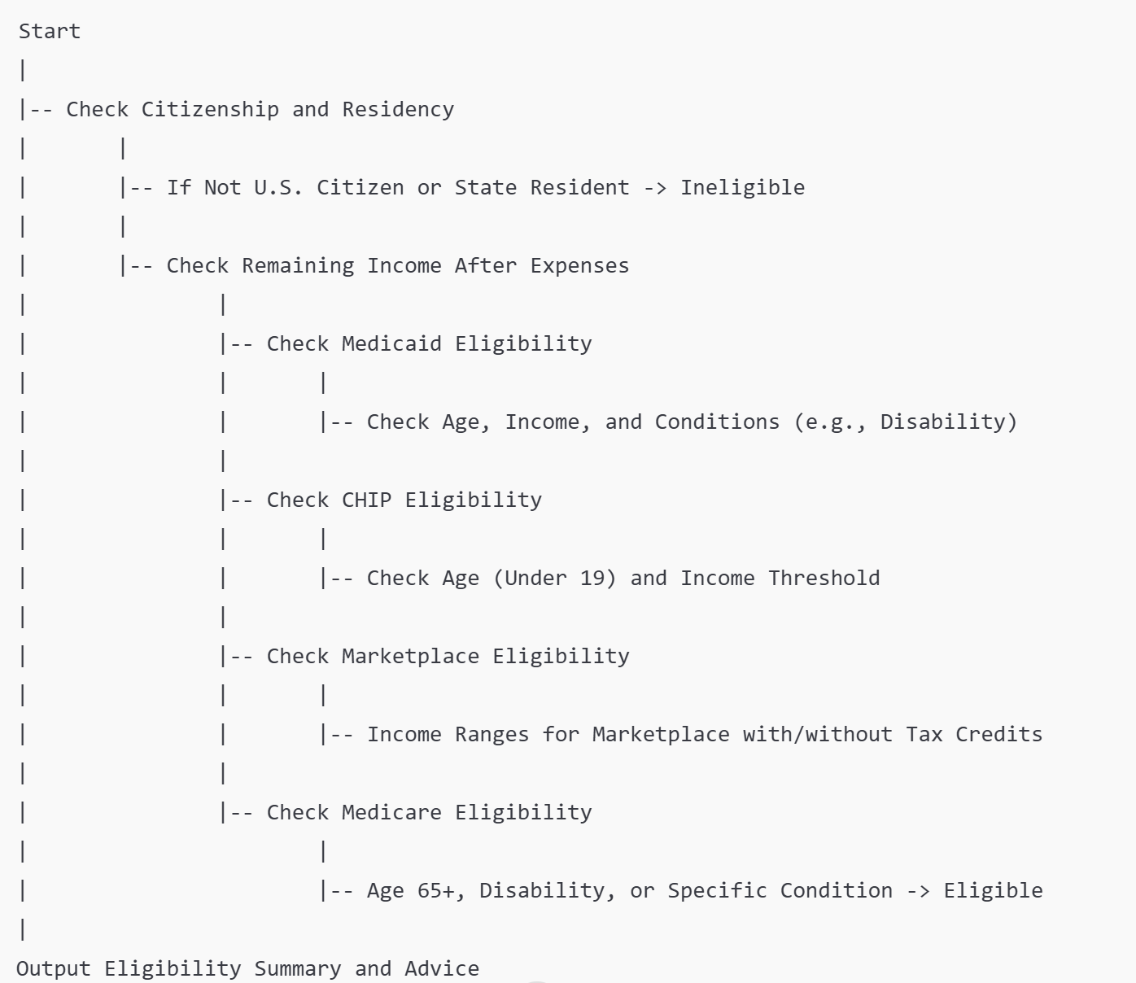

1. Medicaid Eligibility

* **Citizenship/Residency**: Must be a U.S. citizen and a resident of the state.
* **Income**: Household income must be below a certain percentage of the Federal Poverty Level (FPL), which varies by state (typically around 138% FPL).
* **Age/Status**: Eligible members include:
  + Individuals under 18
  + Individuals 65 or older
  + Individuals with a disability
  + Individuals with medical necessity
* **Outcome**: If eligible, members can enroll in the state's Medicaid program.

2. CHIP (Children's Health Insurance Program) Eligibility

* **Citizenship/Residency**: Must be a U.S. citizen or qualified non-citizen and a resident of the state.
* **Income**: Household income must be below a certain percentage of the FPL specific to CHIP (varies by state, generally up to 200-317% FPL).
* **Age**: Eligible members are typically those under 19 years of age.
* **Outcome**: If eligible, members can enroll in CHIP for children's health coverage.

3. Marketplace Eligibility

* **Citizenship/Residency**: Must be a U.S. citizen or qualified non-citizen and a resident of the state.
* **Income**: Household income must be between 100% and 400% of the FPL to qualify for premium tax credits. If income is below 100% FPL, the individual may qualify for Medicaid instead.
* **Age**: No specific age requirement, but individuals aged 18 and over may apply for plans.
* **Outcome**: If eligible, individuals can enroll in a health plan through the Marketplace, with potential premium tax credits based on income.

4. Medicare Eligibility

* **Age**: Must be 65 years or older.
* **Disability**: Individuals under 65 may qualify if they have a qualifying disability as determined by Social Security Administration.
* **Conditions**: Eligible members include those who are receiving Social Security Disability Insurance (SSDI) for at least 24 months or those with specific medical conditions (e.g., end-stage renal disease or ALS).
* **Outcome**: If eligible, members can enroll in Medicare coverage.

Comprehensive Description of Health Savings Account (HSA)

1. **Definition**:
   * An HSA is a tax-advantaged account that allows individuals to save money specifically for qualifying medical expenses. It is intended to complement high-deductible health plans (HDHPs) by providing a way to save for out-of-pocket healthcare costs.
2. **Eligibility Requirements**:
   * To qualify for an HSA, an individual must:
     + Be covered under a high-deductible health plan (HDHP) that meets specific criteria set by the IRS.
     + Not be covered by other health insurance that is not an HDHP.
     + Not be enrolled in Medicare.
     + Not be claimed as a dependent on someone else's tax return.
3. **Tax Benefits**:
   * Contributions to an HSA are tax-deductible, meaning that they can reduce your taxable income.
   * The funds in the account grow tax-free, meaning you don’t pay taxes on interest or investment gains.
   * Withdrawals from an HSA for qualified medical expenses are also tax-free.
   * Unused funds can roll over year to year, and there is no expiration on the account.
4. **Contribution Limits**:
   * The IRS sets annual contribution limits for HSAs, which may vary each year. For 2024, the contribution limits are:
     + Individual coverage: $3,850
     + Family coverage: $7,750
     + Individuals age 55 and older can make an additional catch-up contribution of $1,000.
5. **Qualified Medical Expenses**:
   * Qualified medical expenses include costs such as:
     + Doctor visits
     + Prescription medications
     + Preventive care
     + Dental and vision care
     + Certain over-the-counter medications (with a prescription)
   * It's important to keep receipts for all qualified expenses.
6. **Implications of Withdrawals**:
   * If HSA funds are used for non-qualified expenses before age 65, the amount withdrawn is subject to income tax and a 20% penalty.
   * After age 65, funds can be used for any purpose without penalty, though non-qualified withdrawals will still be subject to income tax.

### **Healthcare Ecosystem Prototype with Real-World Companies and Clear Input-Output Relationships**

#### Integrated Flow Breakdown

##### Step 1: Camper Health (Patient Journey Begins)

* **Flow**: The patient first contacts **Camper Health** to begin their healthcare journey.
* **Purpose**: **Camper Health** assesses the patient’s financial eligibility based on their income and other factors to determine if they qualify for subsidized care.
* **Example**: A low-income patient approaches **Camper Health**, and they assess the patient’s eligibility for financial assistance (e.g., for telehealth services or in-person care).

##### Step 2: Camper Health → Homeward Health (Eligibility Sharing for Telehealth Services)

* **Flow**: Once **Camper Health** determines the patient's eligibility, it sends **Eligibility Data** to **Homeward Health**.
* **Purpose**: **Homeward Health** uses this data to determine if the patient qualifies for subsidized telehealth services, facilitating access to care.
* **Example**: A patient is found to qualify for telehealth services based on their eligibility data from **Camper Health**, so **Homeward Health** arranges the necessary care.

##### Step 3: Homeward Health → Main Street Health (Visit Data Sharing for Care Coordination)

* **Flow**: After the telehealth consultation, **Homeward Health** shares **Visit Data** (such as treatment details and follow-up instructions) with **Main Street Health**.
* **Purpose**: **Main Street Health** coordinates care and ensures the patient follows up on any necessary in-person visits or specialists.
* **Example**: The patient may need to visit a local clinic for a follow-up after their telehealth session. **Main Street Health** facilitates this by sending the visit data to the clinic.

##### Step 4: Main Street Health → ProCredEx (Care Summary and Credentialing Data Sharing)

* **Flow**: **Main Street Health** sends **Care Summaries** (e.g., updates on treatment, progress, and future care needs) and provider credentialing information to **ProCredEx**.
* **Purpose**: **ProCredEx** verifies that the care data is compliant with healthcare standards and updates provider credentialing if necessary.
* **Example**: **ProCredEx** verifies that a rural clinic is compliant with regulations and ensures the provider’s credentials are up to date for continued service.

##### Step 5: ProCredEx → Lilian Care (Credential Data for Provider Incentives)

* **Flow**: **ProCredEx** shares **Credential Data** with **Lilian Care**.
* **Purpose**: **Lilian Care** evaluates the data to determine if healthcare providers working in rural or underserved areas are eligible for incentives or bonuses.
* **Example**: A rural provider who is compliant and meets performance metrics receives an incentive, ensuring retention and support for healthcare providers in underserved regions.

##### Step 6: Lilian Care → ProCredEx (Incentive Data Feedback for Compliance Reporting)

* **Flow**: **Lilian Care** shares **Incentive Data** back with **ProCredEx**.
* **Purpose**: **ProCredEx** updates its compliance and credentialing records based on the incentives given to healthcare providers.
* **Example**: **ProCredEx** tracks that a rural provider received an incentive, linking this data to the provider’s compliance and performance, which helps strengthen compliance reporting.

##### Step 7: ProCredEx → Hi.Health (Claims Processing Data for Validation)

* **Flow**: **ProCredEx** sends **Claims Processing Data** to **Hi.Health** for validation.
* **Purpose**: **Hi.Health** checks the claims for accuracy and ensures that they align with the treatment plan and all necessary compliance standards.
* **Example**: **Hi.Health** validates a claim for a telehealth visit, ensuring the service provided matches the patient’s documented care and that the claim is compliant.

##### Step 8: Hi.Health → Walnut (Payment Plan Status & Reimbursement Data)

* **Flow**: **Hi.Health** sends **Payment Plan Status** and **Reimbursement Data** to **Walnut**.
* **Purpose**: **Walnut** uses this data to confirm if the patient is eligible for payment plans and to process any reimbursements based on the approved claims.
* **Example**: **Hi.Health** confirms the patient's payment plan status and sends the information to **Walnut**, which processes the reimbursement and ensures the clinic is paid correctly.

##### Step 9: Walnut → Camper Health (Communication of Financial Assistance Status)

* **Flow**: **Walnut** shares updates about **Payment History** and **Financial Assistance** with **Camper Health**.
* **Purpose**: **Camper Health** uses this information to reassess the patient’s financial situation and adjust their eligibility for financial assistance if needed.
* **Example**: If a patient misses a payment, **Camper Health** may reassess their eligibility for continued financial assistance or offer alternative options based on their current financial status.

##### Summary of Workflow Starting with Camper Health (and Including Lilian Care and Hi.Health):

1. **Camper Health** initiates the patient journey by assessing **financial eligibility**.
2. **Camper Health** shares **Eligibility Data** with **Homeward Health** to arrange **telehealth services**.
3. **Homeward Health** sends **Visit Data** to **Main Street Health** for **care coordination**.
4. **Main Street Health** sends **Care Summaries** to **ProCredEx** for **credentialing verification** and compliance tracking.
5. **ProCredEx** sends **Credential Data** to **Lilian Care** to evaluate provider **incentives**.
6. **Lilian Care** sends **Incentive Data** back to **ProCredEx** to update **compliance records**.
7. **ProCredEx** sends **Claims Processing Data** to **Hi.Health** for **validation**.
8. **Hi.Health** sends **Payment Plan Status & Reimbursement Data** to **Walnut** for processing and reimbursement management.
9. **Walnut** sends updates about **Payment History** and **Financial Assistance** to **Camper Health**.

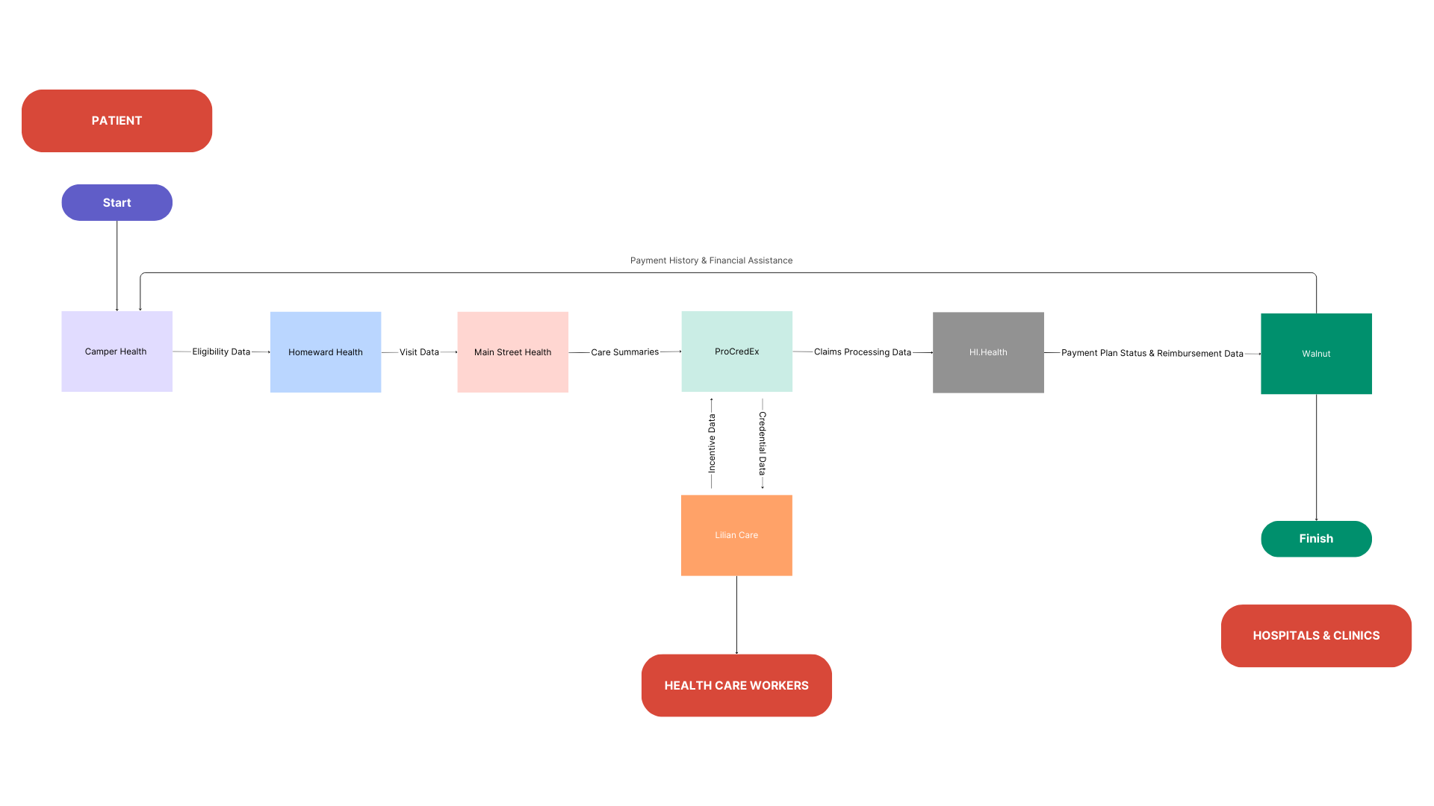

### What kind of solution would address 1. Patients awareness (non-elderly) for eligibility and financial assistance + 2. Medicaid Providers incentives to work in Rural hospitals + overcoming low reimbursement for hospitals in rural areas?

### This integrated system of existing solutions if they work together as one ecosystem.

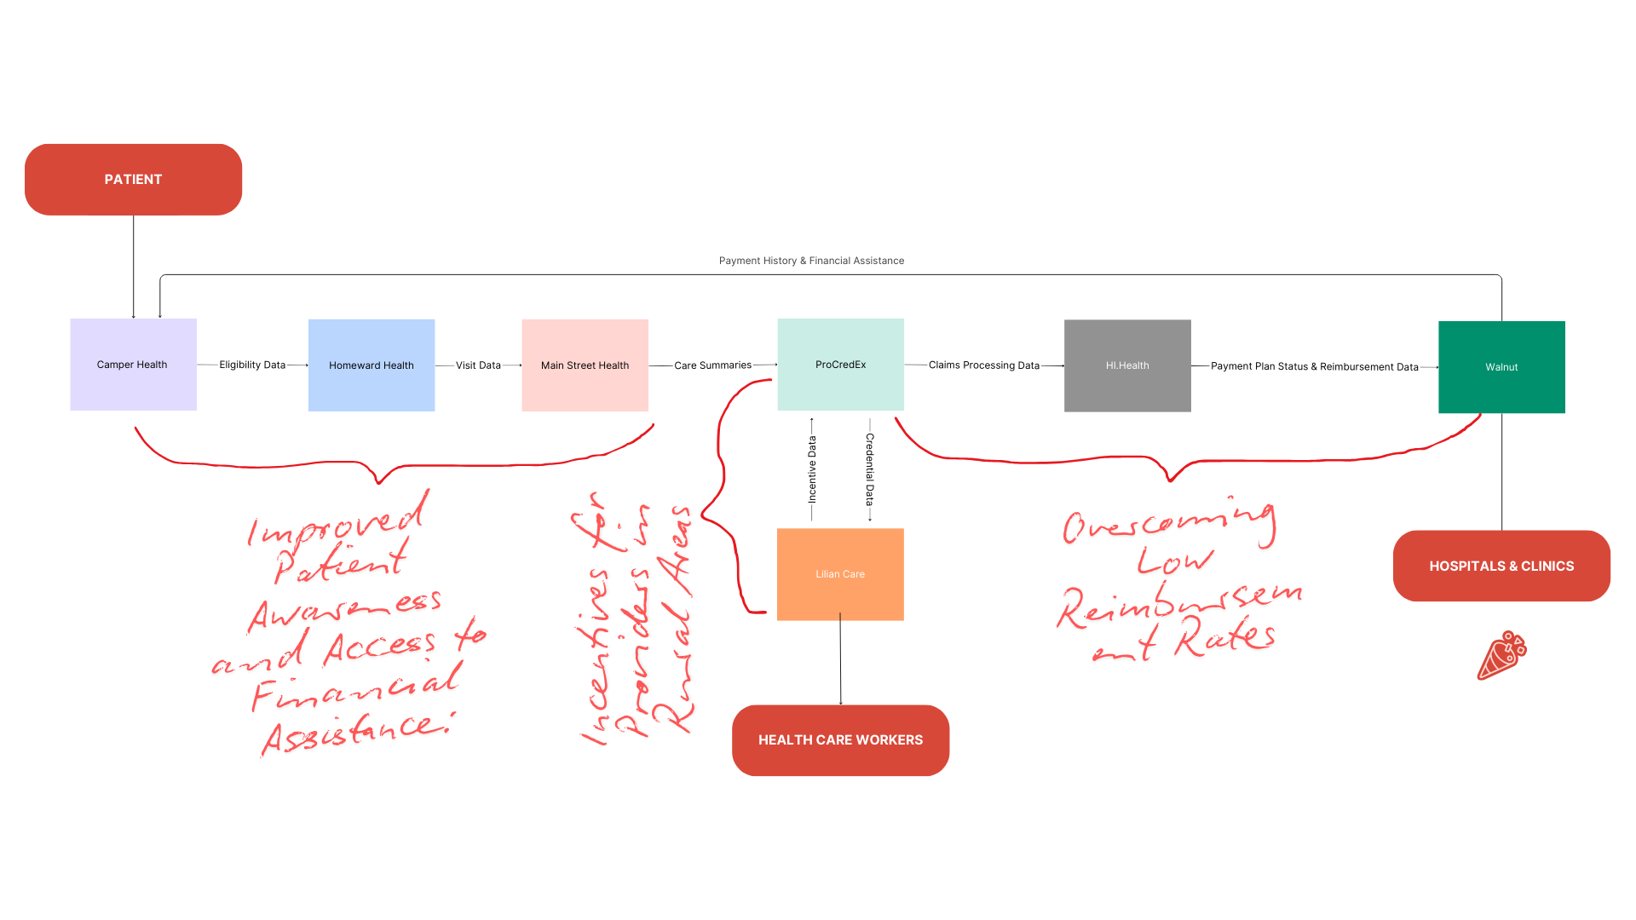

This system addresses gaps identified in the health care:

##### Problem 1: Patients’ Awareness (Non-Elderly) for Eligibility and Financial Assistance

Gap Addressed: Lack of awareness among non-elderly patients about their eligibility for financial assistance, particularly in accessing healthcare services, including telehealth.

###### Solution:

* **Camper Health → Homeward Health → Main Street Health**: This part of the system directly addresses the issue of financial eligibility and streamlines access to care based on financial assistance.
  + **Camper Health** determines a patient’s eligibility for subsidized care, such as Medicare or other assistance, and shares this data with **Homeward Health**.
  + **Homeward Health**, in turn, uses this data to ensure that patients are aware of their qualification for telehealth and in-person services at little or no upfront cost. By leveraging digital platforms, **Homeward Health** ensures that even younger, non-elderly patients are aware of and can access services without needing complex navigation through government or insurance systems.
  + **Main Street Health’s** role as a navigator ensures that patients understand their financial eligibility and how it ties into their care journey, ensuring continuous engagement with the patient.

###### How the Integrated System Solves the Problem:

* **Proactive awareness**: The system helps inform patients about their eligibility early in the care process (through **Camper Health**).
* **Accessible care**: Non-elderly patients, especially those in rural or underserved areas, can easily access telehealth services once eligibility is confirmed by **Homeward Health**, ensuring affordable care.
* **Clear guidance and coordination**: **Main Street Health** acts as a bridge to help patients navigate the process, ensuring they understand how their financial assistance fits into their care plan.

##### Problem 2: Medicaid Providers' Incentives to Work in Rural Hospitals

Gap Addressed: Incentives for healthcare providers to work in rural or underserved areas, where there is a shortage of medical professionals due to low reimbursement rates and other factors.

###### Solution:

* **ProCredEx → Lilian Care → ProCredEx**: This flow addresses the issue of incentivizing healthcare providers to work in rural areas.
  + **ProCredEx** shares **credentialing data** with **Lilian Care**, which evaluates healthcare providers' performance in rural areas and determines eligibility for **incentives or bonuses**.
  + **Lilian Care**, focusing on providers working in underserved areas, provides financial and retention incentives (such as bonuses) based on their compliance and credentialing status, which are verified by **ProCredEx**.
  + **ProCredEx** closes the loop by ensuring the incentive data is recorded and aligned with compliance and provider performance metrics.

###### How the Integrated System Solves the Problem:

* **Provider incentives**: **Lilian Care** ensures that rural providers receive performance-based incentives, encouraging them to stay in underserved areas.
* **Retention of skilled workers**: These incentives directly address the shortage of providers in rural hospitals by offering bonuses and other rewards for meeting key performance and compliance metrics.
* **Easier monitoring**: **ProCredEx** ensures that compliance and incentive data is transparent, making it easier for hospitals to track and retain qualified providers.

##### Problem 3: Overcoming Low Reimbursement for Hospitals in Rural Areas

Gap Addressed: Low reimbursement rates for hospitals in rural areas, making it financially difficult for them to sustain operations and provide adequate care.

###### Solution:

* **ProCredEx → Walnut → Hi.Health → Camper Health**: This flow addresses the low reimbursement rates by ensuring that care is properly validated, compliant, and reimbursed.
  + **ProCredEx** ensures that all care data and claims are compliant with healthcare standards. It works with **Walnut**, which ensures that only compliant claims are reimbursed, and payment plans are managed efficiently to help rural hospitals with cash flow.
  + **Hi.Health** validates claims processing, ensuring that **Walnut** has the necessary payment information and reimbursement status to facilitate timely payments to healthcare providers.
  + The communication between **Hi.Health** and **Camper Health** ensures that financial assistance or patient payment plans are reviewed regularly, which can include extending assistance or reassessing a patient’s eligibility, preventing missed payments and supporting rural hospitals.

###### How the Integrated System Solves the Problem:

* **Timely reimbursement**: The **ProCredEx → Hi.Health → Walnut**  system ensures that rural hospitals receive reimbursement for the care they provide, reducing the financial strain caused by low reimbursement rates.
* **Streamlined claims and payment processing**: With **Hi.Health** validating claims and **Walnut** handling payment plans, hospitals can better manage cash flow and ensure they receive fair compensation for services provided.
* **Financial assistance coordination**: **Camper Health** ensures that patients' financial needs are continuously evaluated, allowing rural hospitals to adjust care pricing or offer financial assistance to patients who are unable to pay, thus maintaining patient volume.

#### Summary of Problems Solved by the Integrated System

1. **Improved Patient Awareness and Access to Financial Assistance**:
   * **Camper Health**, **Homeward Health**, and **Main Street Health** work together to ensure non-elderly patients are aware of their eligibility for financial assistance and can easily access telehealth and in-person services. The integration reduces confusion and barriers to care for patients in rural areas.
2. **Incentives for Providers in Rural Areas**:
   * **ProCredEx** and **Lilian Care** ensure that healthcare providers working in rural areas receive performance-based incentives. These incentives help retain skilled workers and ensure that providers in underserved areas remain motivated and adequately supported.
3. **Overcoming Low Reimbursement Rates**:
   * **ProCredEx**, **Walnut**, and **Hi.Health** form a comprehensive financial ecosystem that ensures accurate claims processing and timely reimbursements for rural hospitals. This helps alleviate the financial burden caused by low reimbursement rates and improves cash flow for rural healthcare providers.

By integrating these solutions into a cohesive system, **patients** gain improved access to financial assistance, **providers** are incentivized to work in rural areas, and **rural hospitals** benefit from more predictable and timely reimbursement, creating a healthier and more sustainable rural healthcare ecosystem.

#### Three Different Patient Scenarios

We'll provide three patient inputs with different eligibility, medical conditions, and financial statuses to demonstrate varied outcomes in the journey:

#### **Scenario 1**: **Low-income family, Medicaid and CHIP eligible**.

#### **Scenario 2**: **Mid-income individual, eligible for marketplace coverage**.

#### **Scenario 3**: **Senior individual with disability, eligible for Medicaid and Medicare**.

Scenario 1: Low-Income, Single Parent with a Young Child in Rural Area (Eligible for Medicaid and CHIP)

**Patient Details:**

* Income: $18,000
* Family size: 2 (single parent and 5-year-old child)
* Ages: [30, 5]
* State: Texas
* Citizenship: U.S. citizen
* Residency: State resident
* Medical necessity: No
* Disability: [False, False]
* Expenses: {"passive": 500, "active": 1000}

Execution and Outcomes:

1. **Health Insurance Eligibility:**
   * Medicaid eligible for both the parent and the child (income under threshold).
   * CHIP eligible for the child (age <19).
   * Medicare not applicable.
   * **Advice**: Apply for Medicaid and CHIP.
2. **Homeward Health Visit**:
   * Simulate a **routine** telehealth check-up.
   * **Visit outcome**: "Routine check-up provided. No immediate concerns."
3. **Care Coordination by MainStreetHealth**:
   * **Care coordination**: "Scheduled telehealth appointment with a local specialist."
4. **Provider Incentives by LilianCare**:
   * Provider incentives include a **bonus for rural area service** and **experience-based bonus** due to high patient satisfaction.
   * **Incentives**: {"provider_id": 1, "incentive": "Bonus for working in rural area and providing primary care + Experience-based bonus + High patient satisfaction bonus"}
5. **Credential Updates by ProCredEx**:
   * Provider’s credentials are **compliant**.
   * **Credential updates**: {"provider_id": 1, "status": "Compliant - No action required."}
6. **HiHealth Claims Processing**:
   * Emergency services claim for the child.
   * **Claim status**: Approved for Medicaid, "Full coverage under Medicaid."
7. **Payment Processing**:
   * Since income is low and the family qualifies for Medicaid, **no payment required** for both emergency and routine services.
   * **Payment Plan**: "Emergency services covered by Medicaid. No payment required."

Scenario 2: Middle-Income Family in Suburban Area, No Medicaid Eligibility but Marketplace Subsidies Available

**Patient Details:**

* Income: $45,000
* Family size: 4 (two adults, one 16-year-old child, and one 5-year-old child)
* Ages: [40, 38, 16, 5]
* State: California
* Citizenship: U.S. citizen
* Residency: State resident
* Medical necessity: Yes for one adult
* Disability: [False, True, False, False]
* Expenses: {"passive": 1200, "active": 2000}

Execution and Outcomes:

1. **Health Insurance Eligibility**:
   * **Not eligible for Medicaid or CHIP** (income above thresholds).
   * Eligible for **marketplace coverage with premium tax credits**.
   * **Advice**: Consider enrolling in a marketplace plan.
2. **Homeward Health Visit**:
   * Simulate an **urgent** care visit.
   * **Visit outcome**: "Urgent care provided. Follow-up with primary care scheduled."
3. **Care Coordination by MainStreetHealth**:
   * **Care coordination**: "Emergency care scheduled at local hospital."
4. **Provider Incentives by LilianCare**:
   * Suburban provider with **standard incentive**; no additional bonuses.
   * **Incentives**: {"provider_id": 2, "incentive": "Standard incentive for suburban providers"}
5. **Credential Updates by ProCredEx**:
   * Provider’s credentials **require review**.
   * **Credential updates**: {"provider_id": 2, "status": "Review required due to policy update or performance assessment."}
6. **HiHealth Claims Processing**:
   * Routine services claim for 5-year-old.
   * **Claim status**: Not covered by Medicaid or CHIP, full payment required.
7. **Payment Processing**:
   * Marketplace subsidies help, but **reduced payment plan** for routine services due to family size.
   * **Payment Plan**: "Reduced payment plan for routine services available. Installments possible."

Scenario 3: High-Income Elderly Couple with Medicare Eligibility and Emergency Services

**Patient Details:**

* Income: $70,000
* Family size: 2 (two elderly adults)
* Ages: [70, 68]
* State: California
* Citizenship: U.S. citizen
* Residency: State resident
* Medical necessity: No
* Disability: [False, False]
* Expenses: {"passive": 2000, "active": 1500}

Execution and Outcomes:

1. **Health Insurance Eligibility**:
   * **Not eligible for Medicaid or CHIP** due to high income.
   * **Eligible for Medicare**.
   * **Advice**: Apply for Medicare for healthcare needs.
2. **Homeward Health Visit**:
   * Simulate a **routine** telehealth check-up.
   * **Visit outcome**: "Routine check-up provided. No immediate concerns."
3. **Care Coordination by MainStreetHealth**:
   * **Care coordination**: "Scheduled telehealth appointment with a local specialist."
4. **Provider Incentives by LilianCare**:
   * **Standard incentive for suburban provider**; no additional bonuses.
   * **Incentives**: {"provider_id": 3, "incentive": "Standard incentive for suburban providers"}
5. **Credential Updates by ProCredEx**:
   * Provider’s credentials are **pending review**.
   * **Credential updates**: {"provider_id": 3, "status": "Pending review - decision pending based on recent evaluation."}
6. **HiHealth Claims Processing**:
   * Emergency services claim.
   * **Claim status**: Approved under Medicare, "Full coverage under Medicare."
7. **Payment Processing**:
   * High income means **co-payment may apply for emergency care** despite Medicare coverage.
   * **Payment Plan**: "Emergency services covered. However, co-payment may apply based on income."

### 